Greensheets Document Checker
Software Architecture Document

Version 1.0

Revision History
Date | Version | Description | Author
31/Mar/2008 | 1.0 | Software Architecture Document for the Greensheets Document Checker | Abdul Latheef - Number Six Software

Table of Contents
1. Introduction 4
1.1 Purpose 4
1.2 Scope 4
1.3 Definitions, Acronyms, and Abbreviations 4
1.4 References 4
1.5 Overview 4
2. Architectural Representation 4
3. Architectural Goals and Constraints 4
4. Use-Case View 4
5. Logical View 5
5.1 Overview 5
5.2 Architecturally Significant Design Packages 5
5.3 Use-Case Realizations 5
6. Process View 5
7. Deployment View 5
8. Implementation View 5
8.1 Overview 5
8.2 Layers 5
9. Data View (optional) 6
10. Size and Performance 6
11. Quality 6

Software Architecture Document

Introduction

Purpose
This document provides a comprehensive architectural overview of the Greensheets Document Checker system, using a number of different architectural views to depict different aspects of the system. It is intended to capture and convey the significant architectural decisions which have been made on the system for the benefit of "technical" team members joining the team.

Scope
The Greensheets Document Checker is scheduled to run periodically to track the files missing on the file system where the Greensheets application is storing those files attached to greensheets by its users.

References

Refer to Software Architecture Document in the location below:
https://subversion.nci.nih.gov/svn/iscs/greensheets/Operations and Support/Greensheets Attachments Reconciliation Guide.doc

The User Guides are at the following locations.
https://subversion.nci.nih.gov/svn/iscs/greensheets/Deployment/User Documentation/GS_program.doc
https://subversion.nci.nih.gov/svn/iscs/greensheets/Deployment/User Documentation/GS_specialist.doc
Use case
Model diagrams
Migration Guide.

Overview
The user files that are attached to the questions in Greensheets disappear from the file system after they are stored. Since the cause could not be identified or confirmed yet, the fix has not been made to the Greensheets application itself, which stores the files that are attached by the users online. However, it manual intervention is required to resolve the issue when it happens. The Greensheets Document Checker aids in resolving the issue manually and helps to track the files as and when they disappear.

Architectural Representation
This document presents the architecture as a series of views; use case view, logical view, process view and deployment view.

Architectural Goals and Constraints
There are some key requirements and system constraints that have a significant bearing on the architecture.
The system is being built using the following tools and technologies that are currently being used.
Software Requirements
- Oracle 9i Database Server
- XML Validator
- Oracle 9i Database Client
- Java Activation Framework
- iText Framework
- Apache Commons Configuration
- Java 1.4 SE

The application is a standard J2SE application built to run on a box which has access to the file system and database which stores the Greensheet Users’ files.
The application should not be run behind the firewall which may prohibit it from connecting to the database server to read the data, mail server to send out emails. No special Java security policies should be placed to prohibit this application from accessing the disk where the files are physically stored.
The application should be granted permission to record the date and time the report was generated in an XML file. This is important for the program to run in the incremental mode.
The iText framework consumes too much memory. So when the report approached 2G or more, the JVM runs out of memory. So the application needs to be started with the JVM arguments for heap size for example as shown below. The following command must not be broken into multiple lines, it should all be in a single line.
/usr/java/j2sdk1.4.2_11/bin/java -Xms512M -Xmx1024M -classpath .:$DOCDEPJARS gov.nih.nci.iscs.numsix.apps.docchecker.DocChecker

Since the application while running on local development environment does not have access to the disk where the Greensheets web application stores the attachments, the code needs to be changed to search for the attachments in a local environment. The database does not and cannot be changed to reflect the location of the files stored on the local disk. For the convenience of the programmer, the section of the code that helps test the local environment is commented out.

Use-Case View
[This section lists use cases or scenarios from the use-case model if they represent some significant, central functionality of the final system, or if they have a large architectural coverage—they exercise many architectural elements or if they stress or illustrate a specific, delicate point of the architecture.]

Logical View
[This section describes the architecturally significant parts of the design model, such as its decomposition into subsystems and packages. And for each significant package, its decomposition into classes and class utilities. You should introduce architecturally significant classes and describe their responsibilities, as well as a few very important relationships, operations, and attributes.]
This section provides a description of the logical view of the architecture. It describes the most important classes, their organization in service packages and subsystems, and the organization of these subsystems into layers. Class diagrams may be are included to illustrate the relationships between architecturally significant classes, subsystems, packages and layers.
With respect to use-case realizations, which are used to describe the dynamic aspects of the architecture by explaining how different elements of the architecture work together as a user goes through the steps of a use case – although they can be considered a part of the logical view, they will be presented in separate documents [provide links here when use-case realization documents are available].

Overview
[This subsection describes the overall decomposition of the design model in terms of its package hierarchy and layers.]

Architecturally Significant Design Packages
[For each significant package, include a subsection with its name, its brief description, and a diagram with all significant classes and packages contained within the package.
For each significant class in the package, include its name, brief description, and, optionally, a description of some of its major responsibilities, operations, and attributes.]

Use-Case Realizations
[This section illustrates how the software actually works by giving a few selected use-case (or scenario) realizations, and explains how the various design model elements contribute to their functionality.]

Process View
[This section describes the system's decomposition into lightweight processes (single threads of control) and heavyweight processes (groupings of lightweight processes). Organize the section by groups of processes that communicate or interact. Describe the main modes of communication between processes, such as message passing, interrupts, and rendezvous.]

Deployment View
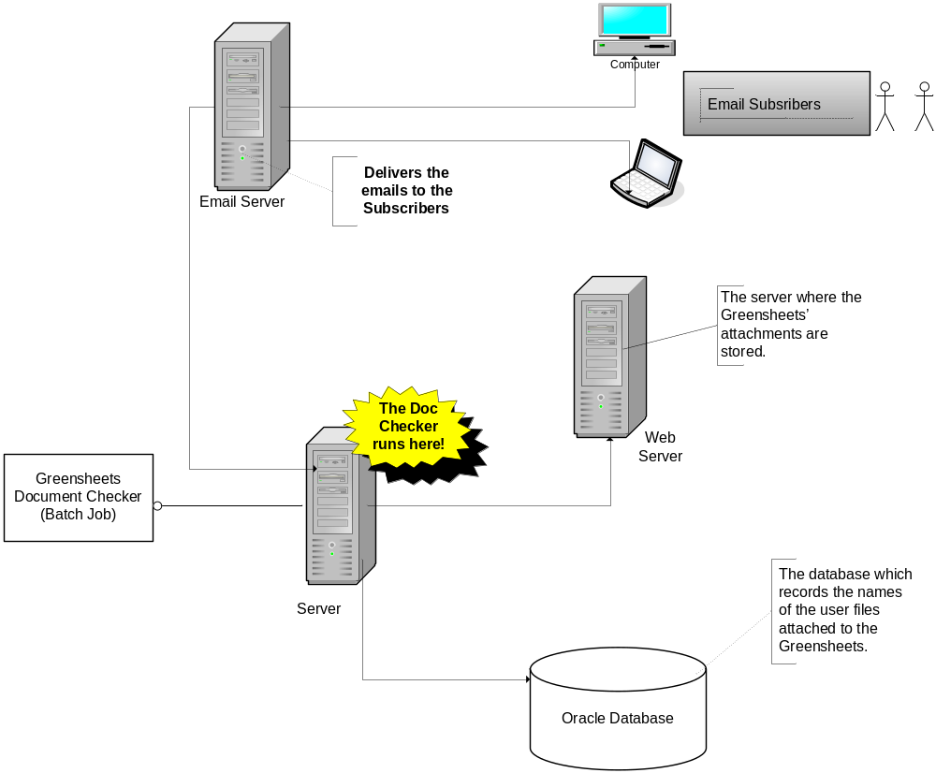

Implementation View
The physical files that are composed to form the implementation view are organized into the following directory structure.
Presentation Layer
The application outputs a .PDF file that is generated to report on the missing files.
.pdf file
Business Layer
The Greensheets Java developers would create the java files that make up the business logic of the system.
.java files

Integration Layer
The Intramural Java developers would create the following files that make up the integration tier of the system.
.java files
Database
The Database layer is implemented in Oracle 9i Enterprise system and is maintained by the Oracle team at NCI.

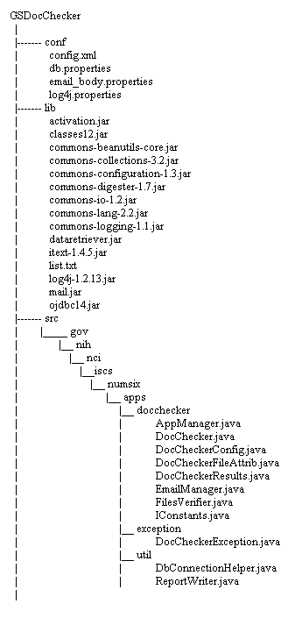

Data View
The primary source of data to the System is the Oracle database. The data view presented here will be limited to the scope of the problem domain addressed by the system.

Oracle Database
The key data elements related to the Greensheets Document Checker are described in the Entity Relationships (ER) Diagram.

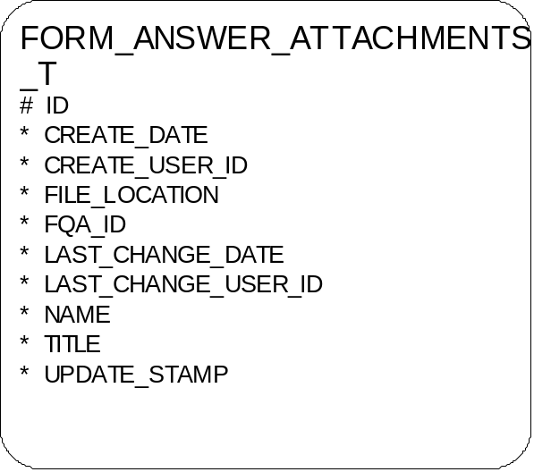

Size and Performance
When the report generated by the Document Checker application reaches 2MB, the JVM runs out of memory. So the JVM needs to be started with a significant Java heap size as specified under the Architectural goals and Constraints section. This is also mentioned in the Deployment/Migration Guide.

Quality
[A description of how the software architecture contributes to all capabilities (other than functionality) of the system: extensibility, reliability, portability, and so on. If these characteristics have special significance, such as safety, security or privacy implications, they must be clearly delineated.]
[We will not initially focus on this section.]

